Cart Recovery Agent- Set Up & Agent Journey
Segment 1- Setting Up the Agent
- Choose an agent
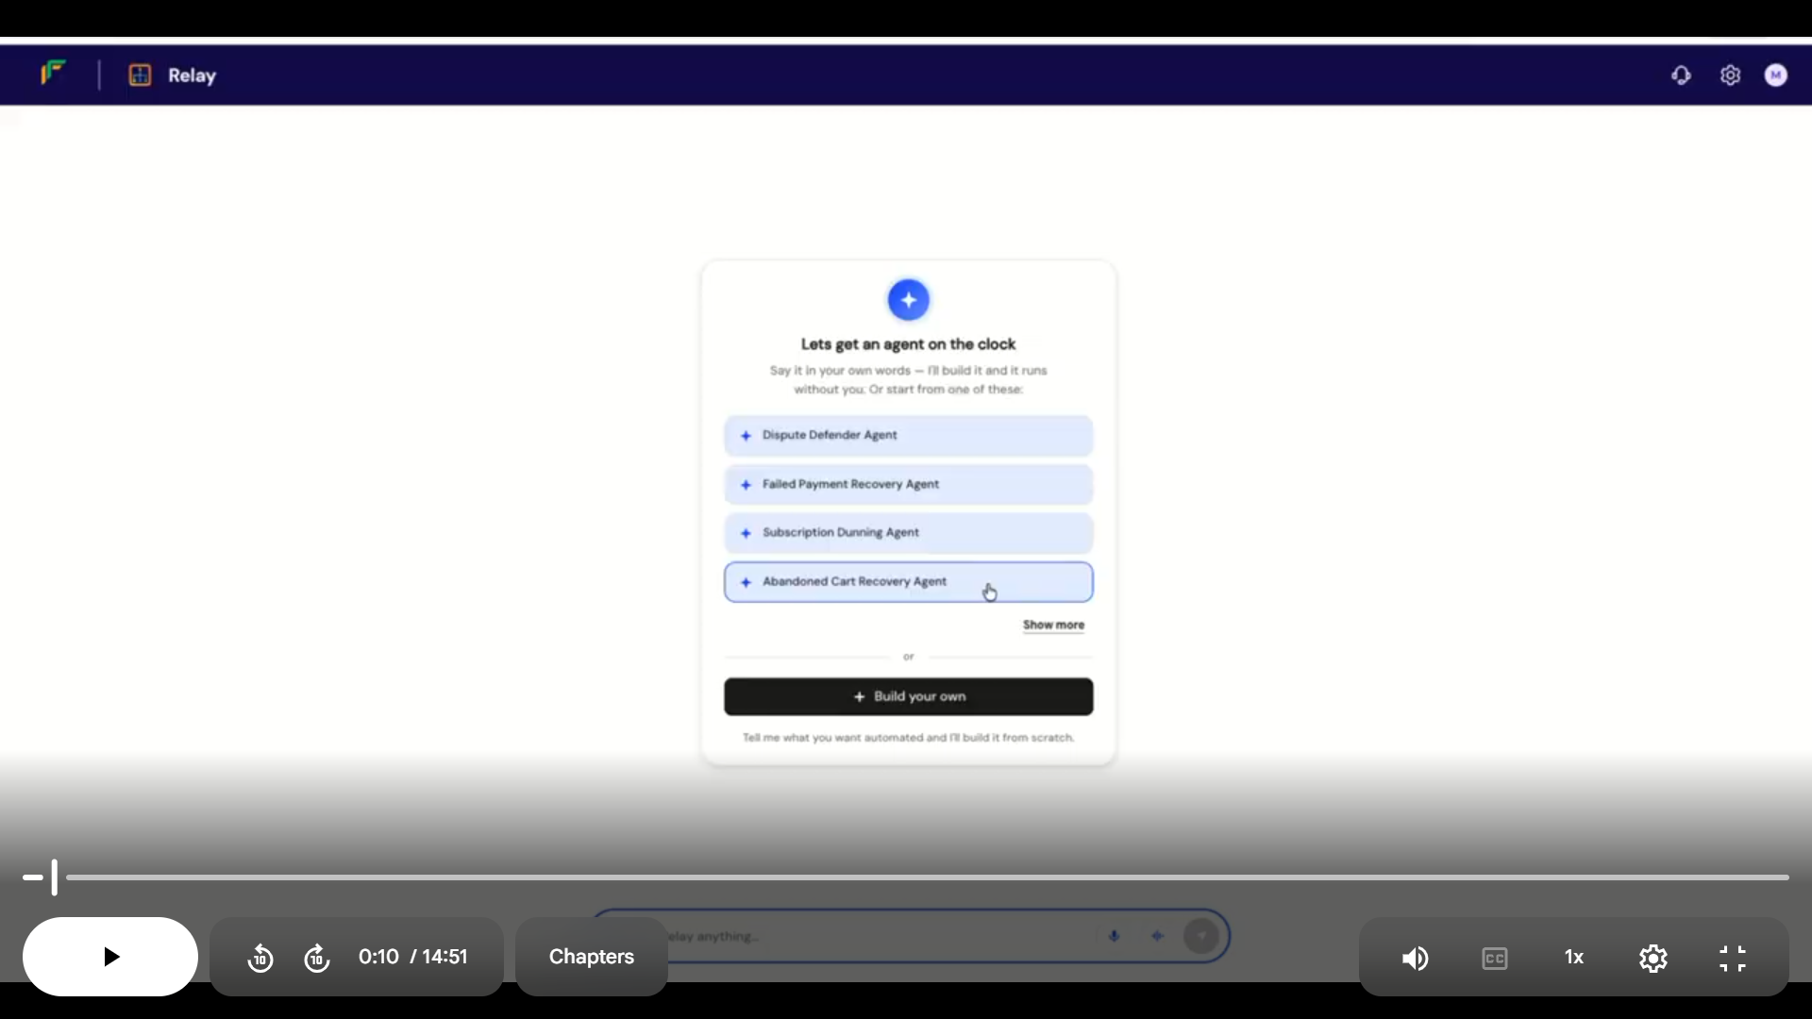
- Speak or type prompt: Can you tell me my transactions for the past month?
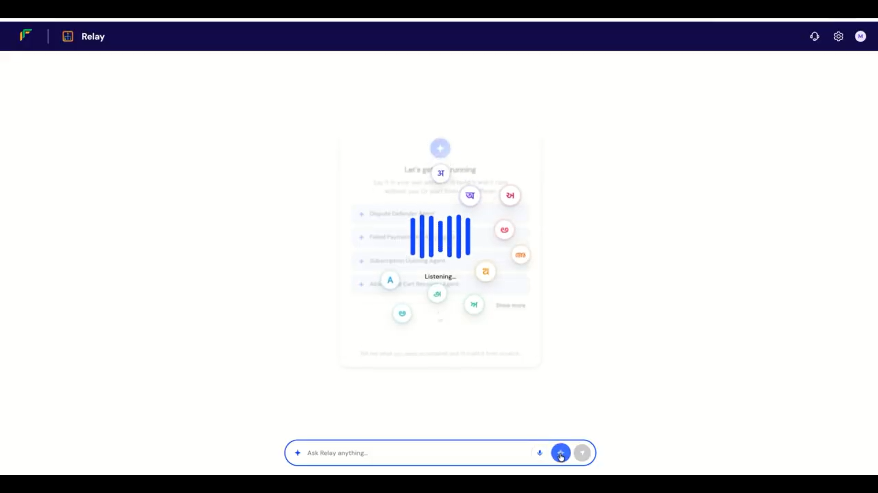
Agent: Would you like to dig into your dropped transactions and set up an agent to help recover them?
User: Yes, do that.
Agent: It’s done. Would you like to do a test run?
User: Yes, let’s do a test run
Agent reports test run successful. The Agent asks whether it should activate the Abandoned Cart Recovery Agent. The user says yes.
Agent: Your Abandoned Cart Recovery Agent is now live.
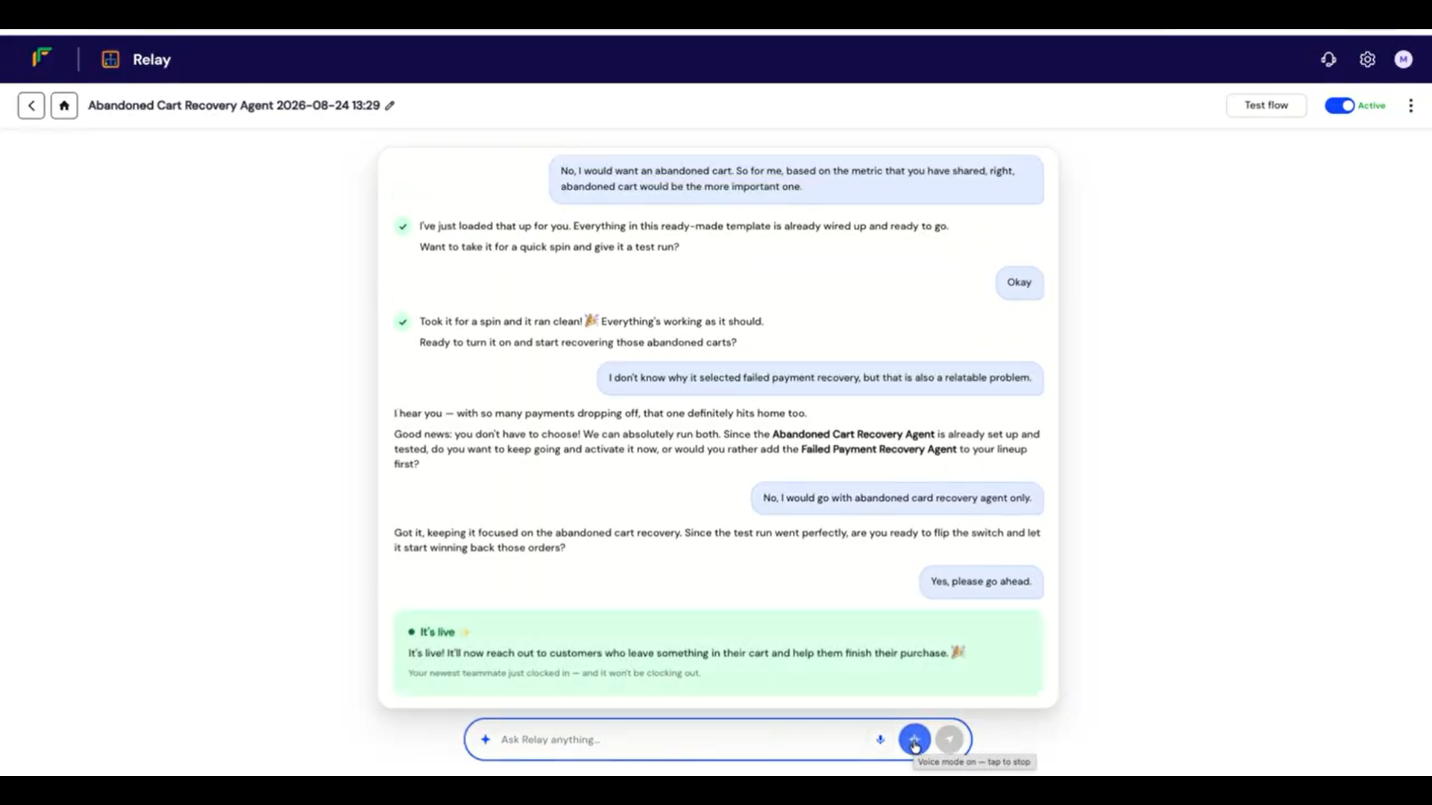

Segment 2- Cart Recovery
Shopify checkout screen- Cart abandoned at checkout by buyer
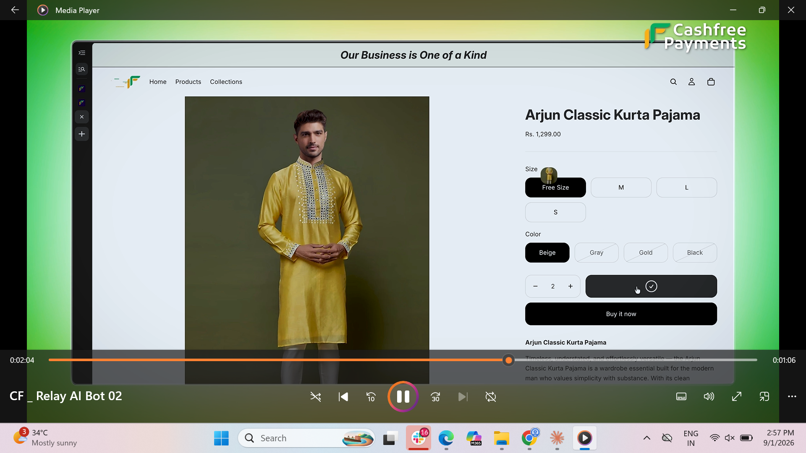
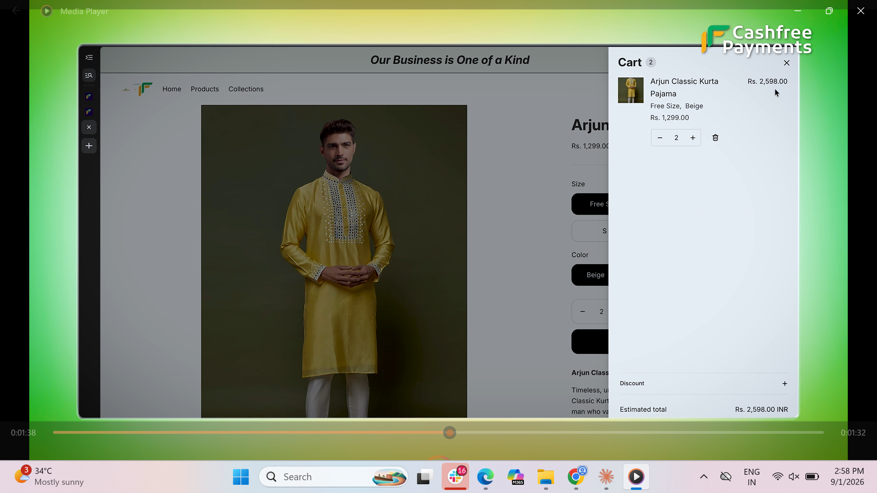
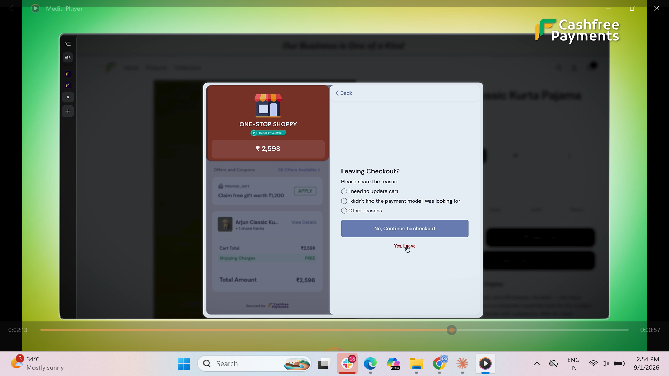
Segment 3: Agent Reaches out to buyer on Call
Phone call UI mockup
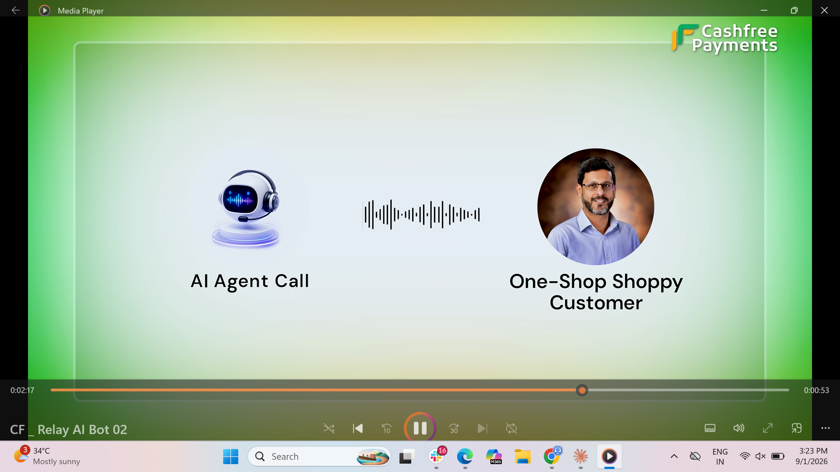
Agent: Hi ABC, I noticed you were checking out. Was there an issue with payment, or just still deciding?
Buyer: Oh yeah, I wanted it but got distracted.
Agent: Here's the payment link. Use the code 5XCA to get 10% off at the checkout.
Buyer: Customer clicks the link, makes the payment. Payment successful tick appears.

